Wed 22/09/2010 8:51 AM
Subject: Consolidation of Storage location – SG15

Hi Epson Team,

As you might have received couple of emails regarding above subject,
the reason of this email was triggered due to change of Storage location requested from Epson:

Pls note that we will consolidate the following storage locations in SAP on 01/09/2010.
A ) SG18 to SG16 ( less ED products )
B ) SG21 to SG15
After the Stock consolidated, SG18 and SG21 will be storage location for ED products only. - Only SG18 will be maintained for ED product. SG21 will be removed.
And SDVI storage will be SG15 / SG16, which will be combined with TP storage.

Impact to system:
1. Outbound M3 Detail billing for SDVI not able to extracted. Due to combination of TP storage location (SG01) with SDVI location (SG15, SG16)
Current logic for is based on storage location, so it not able to cater for the location changes.

Changes request:
Epson requests to change the detail billing logic to group by Epson product Sub-division. That will be needful information to Epson.

System Changes:
- SKU interface file – add new Production hierarchy mapping to SKU master, then this Hierarchy will be mapped to respective Sub-division group.
SKU-> Product hierarchy-> Sub Division -> Division
Refer attached ESP PRODUCT GROUPING FY10.xls for detail product grouping
add the product hierarchy [first 3 characters eg. AAA,AAB...] as the lat column in the file.

File structure:
SG01C11C200902 Philicia test data - pls. do not delete HAWAAAB
AAB is product hierarchy the additional field of 3 char length

- New Product Hierarchy and Sub-division lookup master maintenance list
  - Ops to maintain the master, should there’s new sub-division or product hierarchy
- Billing Reports – combine TP, SDVI Inbound and outbound M3 billing detail reports to group by Epson Sub-division.

** The new billing reports will be effective for month of Sept.

** We’re targeting to cut-off new SKU interface files by 28 Sept.

From: NOORMAN BIN MOHD TAIB [mailto:noorman@esp.epson.com.sg]
Sent: Monday, 16 August, 2010 3:27 PM
To: Foo Pau Ling; Chan Pei Fong
Cc: Tan Hiang; allan.lee; David Tan KC; Morgan Balakrishnan; PETER CHIONG (SCM); ANNIE LIM; GILLIAM ANG; ELENA PANG; DOREEN SOH; NANCY TAY
Subject: Consolidation of Storage location

Hi Pauling,
Pls note that we will consolidate the following storage locations in SAP on 01/09/2010.
A ) SG18 to SG16 ( less ED products )
B ) SG21 to SG15
- For DNs already generated for export under SG18 location, we will not move these allocated SKUs and will maintain it in SG18 until Schenker do the shipwave ( PGI ) . All other SKUs currently not allcoated to any Dns at that point of time will be transferred over.
Pls note that ESP 852 report will consolidate these affected storage locations from 02/09/2010 onwards. So kindly check if you will have any issues arising from this storage location consolidation.
Kindly inform us if you have any enquires.
Regards.

[2010.09.29] System Changes:
- SKU Interface from Epson– add product hierarchy (3 char) at last column of the SKU file.
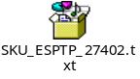
** TP EC changes cut-off as of 28 Sep 2010

- SKU Setup
Add Product Hierarchy
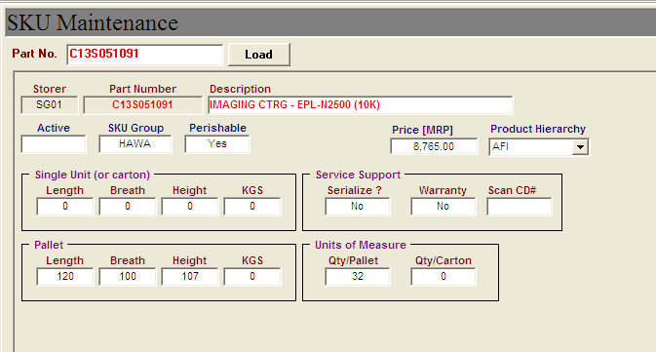

- Code Setup
New Product Hierarchy and Sub-division matrix
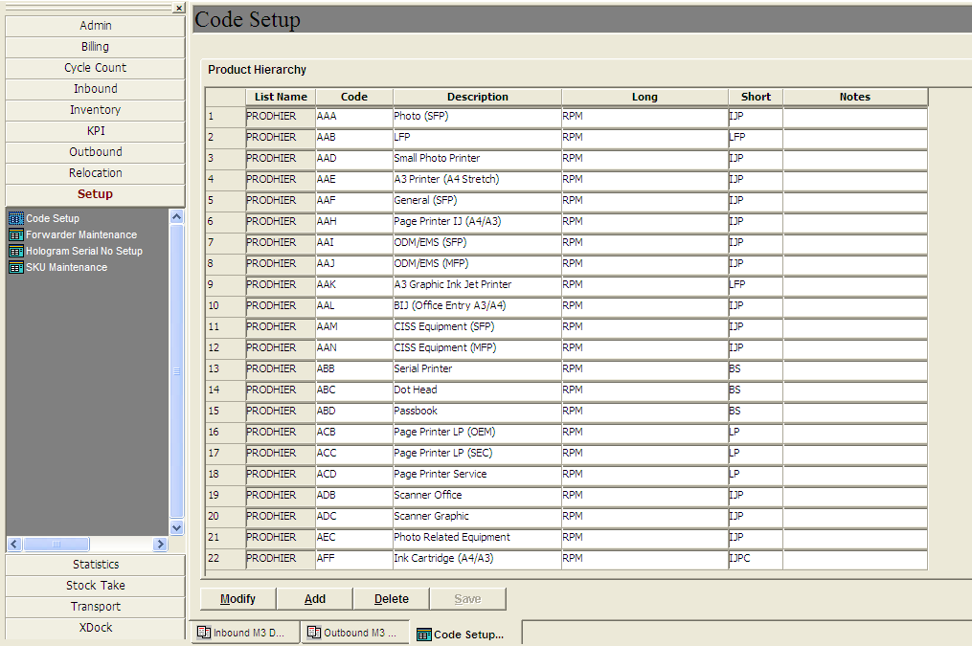
Product Sub-division
- Inbound M3 Detail - Changes: grouping by Sub-division
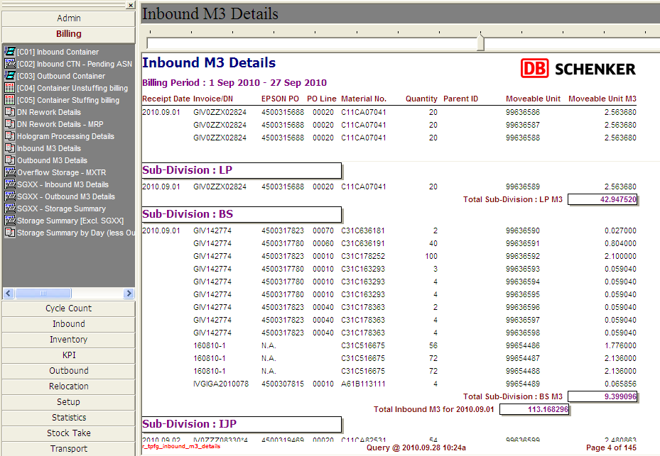

- Outbound M3 Detail - Changes: grouping by Sub-division
